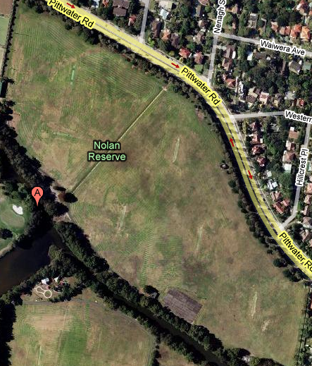
SG 1
SG 2
SG 3
SB 1
SB 2
SB 3
JG 3
JG 2
JG 1
JB 3
JB 2
JB 1
CODE
SB = Senior Boys
SG = Senior Girls
JB = Junior Boys
JG = Junior Girls
Number = field #
PRIMARY PISA MAP
Term 1 – 2012
Venue – Nolan’s Reserve
1st AID

