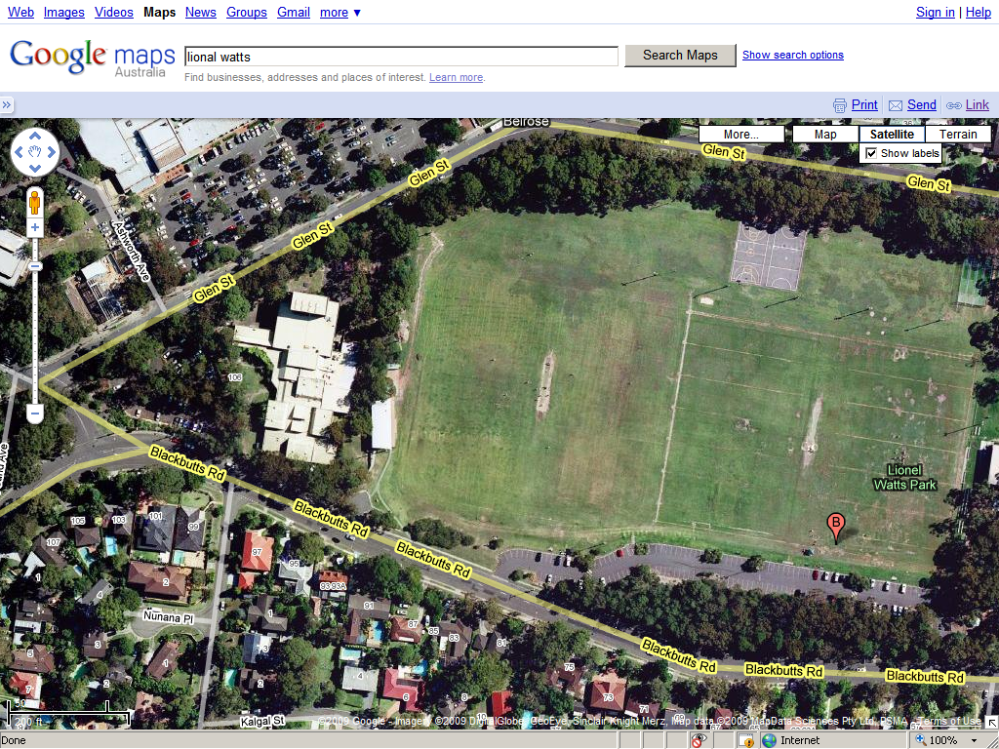
TERM 4 MAP 2011
Mixed Ultimate Frisbee
1
2
3
4

