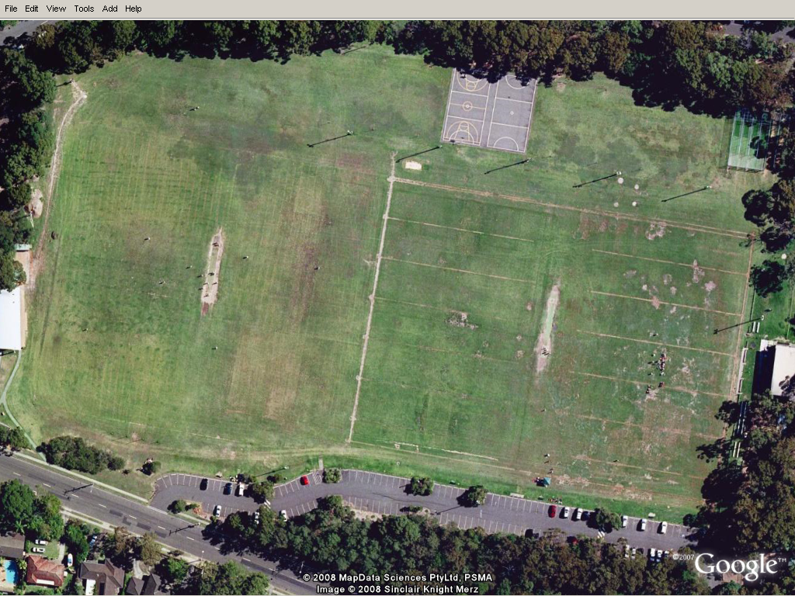

**Term 3 - 2011 – League Tag Map**

**Blue Box** = Boys

**Pink Box** = Girls

**4**

**2**

**3**

**1**